**CNS ASSIGNMENT**

**NAME & ROLL NO.**

20BEC048 – KARTHICK M

20BEC054 – NAVEEN CHANDRA V

**CONTENT**

If spammers notice that all their emails containing “4U” are blocked, they might start writing “For U” instead. A spam filter using traditional programming techniques would need to be updated to flag “For U” emails. If spammers keep working around your spam filter, you will need to keep writing new rules forever.

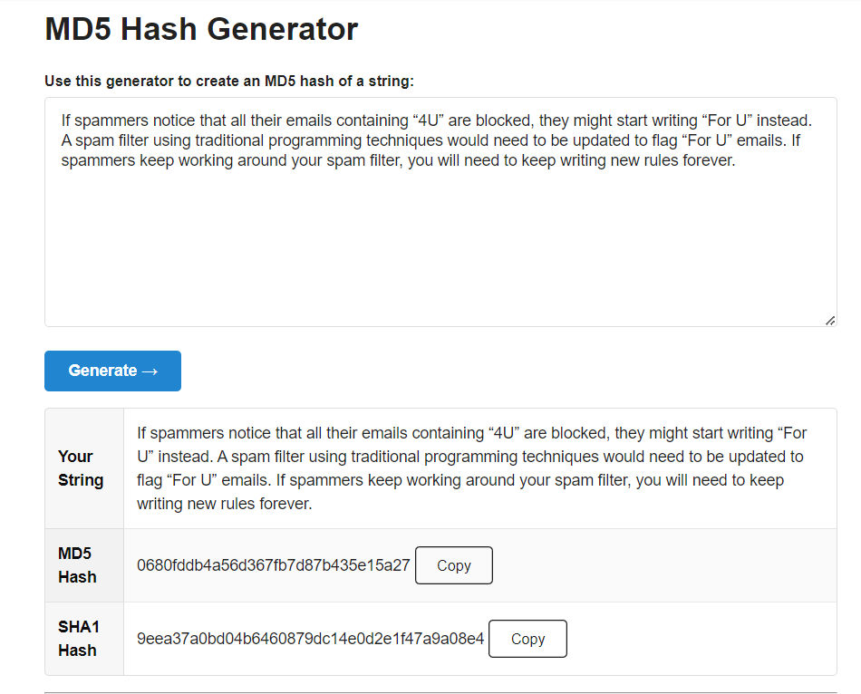**HASH GENERATOR SCREEN SHOT**

**GENERATED HASH CODE**

0680fddb4a56d367fb7d87b435e15a27